**USER’S**

**MANUAL**

*DNS Lookup Form*

Prepared by: Fernando Gutierrez

May, 2020

**USER'S MANUAL**

**TABLE OF CONTENTS**

Page #

1.0 GENERAL INFORMATION 1-1

1.1 System Overview 1-1

1.2 Acronyms and Abbreviations 1-1

2.0 SYSTEM SUMMARY 2-1

2.1 System Configuration 2-1

3.0 USING THE CLIENT APPLICATION 3-1

3.1 Add a domain name you want to lookup 3-1

3.2 Lookup for the records 3-2

3.3 Response 3-3

3.4 Checking the results 3-3

3.5 Failure 3-4

**1.0 GENERAL INFORMATION**

# GENERAL INFORMATION

## 1.1 System Overview

The DNS Lookup form allows you to check the NS and A records of a list of domain names.

It will display in a table the results of the lookup, including the IP addresses that resolve the domain name, as well as the NS records that associate the domain name with the IP addresses.

## 1.2 Acronyms and Abbreviations

DNS – Domain Name Server. Server that translates names to IP addresses.

SQLite – Lightweight Database Engine used to store the information returned by the lookup.

Docker – Containers software that allows you to install modules and software in your server and replicate the configuration in other servers.

Docker compose – Software that allows you to create a set of containers with its own configuration, as well as automatize it.

Apache – Web server software that allows you to host a web site.

HTML – Hypertext Markup Language. It’s the text and code that serves a web page.

PHP - Hypertext Preprocessor. Programming language that allows you to perform tasks in a central server and send the results in HTML format.

Linux - family of open source Unix-like operating systems based on the Linux kernel.

**2.0 SYSTEM SUMMARY**

# SYSTEM SUMMARY

## 2.1 System Configuration

To install this software in your Linux computer, first install docker and docker-compose.

Once installed, create a directory to host the containers that will work as Apache/PHP server.

Then, enter this folder and simply execute the docker compose script to install the required software:

$ sudo docker-compose up –d

Once the docker containers are up and running, make sure the database file has read and write permissions by the Apache user:

$ sudo chmod 666 /www/resources/db/lookup.db

$ sudo chwon –R www-data:www-data /www/resources/db/

That’s it! Now you can access the software at:

<http://localhost/>

**3.0 USING THE CLIENT APPLICATION**

# USING the CLIENT APPLICATION

## 3.1 Add a domain name you want to lookup

In the form, type the domain name you want to lookup and press enter (or click Add to List).

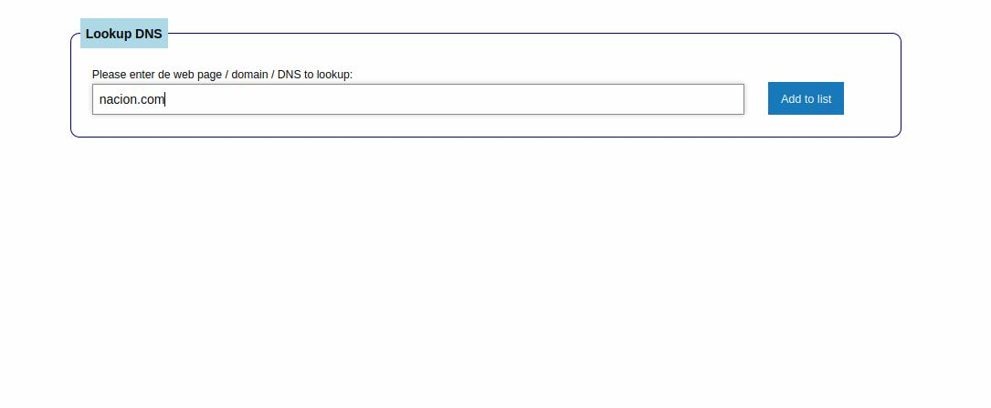

If added properly, you will see a new section like this:

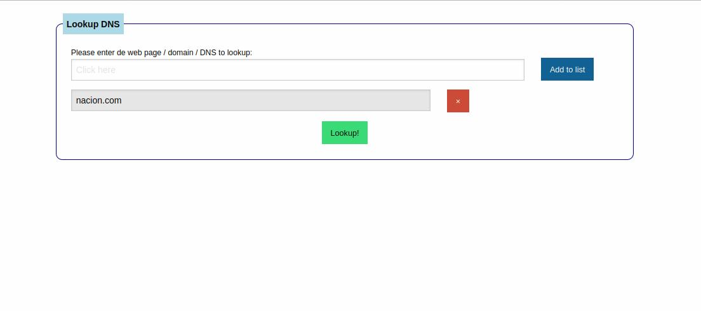

You can remove any of the domain names to lookup by clicking on the red X button next to the domain name.

You can add as many domains to lookup as you want:

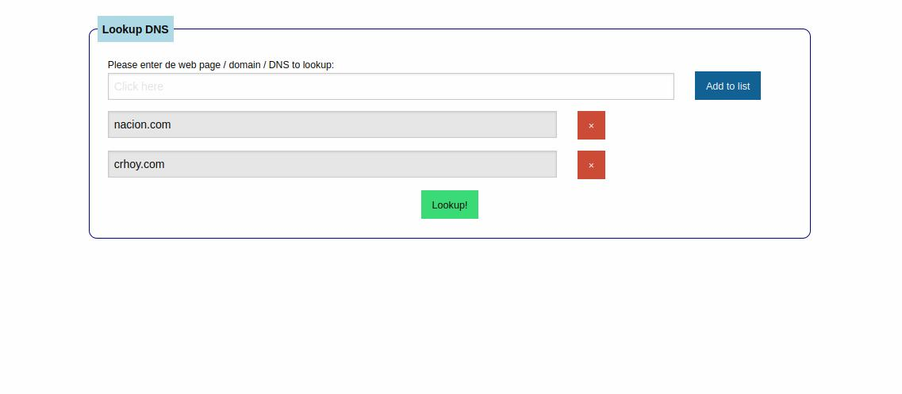

## 3.2 Lookup for the records

Once you have added the domain names you want to lookup, click on the Lookup green button at the bottom of the form. It will send the information to the PHP server to lookup:

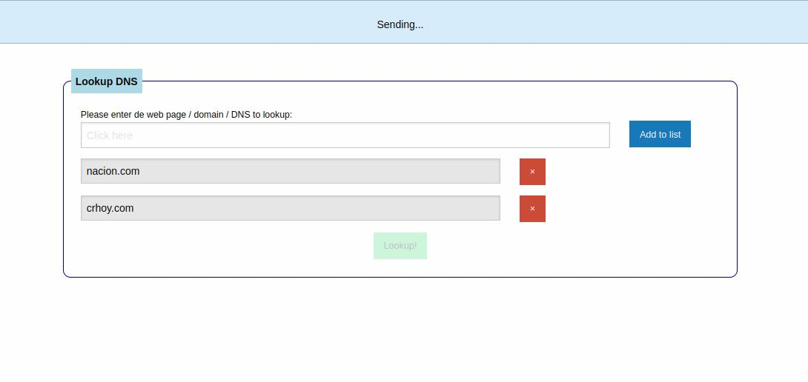

## 3.3 Response

Once the server process the domain names, it will show you a message telling you everything went as expected:

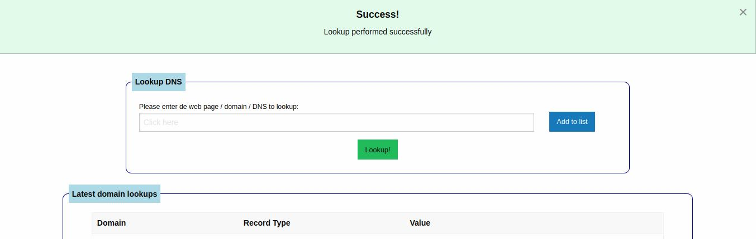

### 

## 3.4 Checking the results

After the server displays the success message, you will see a new table with the latest results:

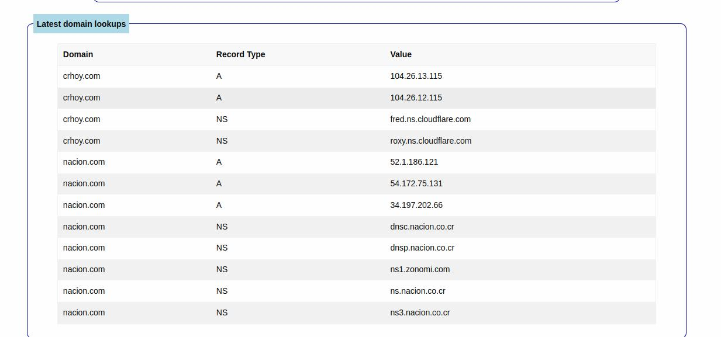

Here you can access the information resulting of the lookup

## 3.5 Failure

In case you enter an invalid domain name, or in case the lookup cannot get the NS and A records, the system will show an alert regarding this problem:

